6/26/2020

Final Project

Finding Best Candy During Halloween

Navya Sri. Medidhi

|  |  |
| --- | --- |
| Table of Contents: | Page no. 1 |
| Introduction | 2 |
| Research Question | 3 |
| Dataset | 4 |
| Machine Learning Techniques | 5-6 |
| Implementation | 7-19 |
| Conclusion | 20-21 |
| References | 22 |

**Introduction:**

In the Halloween season every supermarket needs to take good decision of keeping the candies in stock for the customers to get that candy available in the store. This helps the supermarket to increase the sales that weekend. To figure that out that candy we need to conduct a survey and make people vote. From that data we acquired a good sample of dataset of candy list that are most voted by the survey.

In this survey they have also drawn the data on the specification of the candy ingredients like Chocolate, Fruit, Peanuts & nuts, Crispy, Caramel, Nougat, Multi-piece, Candy bar, Hard Candy. With that data We have also calculate the SugarPercent, PricePercent and WinPercent.

To manufacture a candy that meets the requirements of the customer mainly the candy consumers are children. So, most parents always want to choose a candy that has low sugar candy because of the impact on health of the kid and the kid’s dental concerns as well, with minimum price to get a greater number of candies. These are also the most important parameter that need to be considered to meet the profit graph.

**Research question:**

What is the best Halloween Candy? This was the question this dataset was collected to answer. To predict which candy is best at the time of Halloween and also helps the candy factory to increase the production and improve the quality and maintain the same obsession of that candy and sustain in the top of the charts and gain benefits from the sales. We can also see if that best candy is more chocolaty, more caramel, what will be difference in their costs compared to other candies, and how many customers prefer one over the other candy.

**Dataset:**

This dataset contains attributes of candy along with its ranking with binary variables, 1 means yes, 0 means no. This dataset has all sorts of different data about the kind of candies. All the data in attributes are distributed in binary categorical variables.

* chocolate: Does it contain chocolate?
* fruity: Is it fruit flavored?
* caramel: Is there caramel in the candy?
* peanutalmondy: Does it contain peanuts, peanut butter or almonds?
* nougat: Does it contain nougat?
* crispedricewafer: Does it contain crisped rice, wafers, or a cookie component?
* hard: Is it a hard candy?
* bar: Is it a candy bar?
* pluribus: Is it one of many candies in a bag or box?
* sugarpercent: The percentile of sugar it falls under within the data set.
* pricepercent: The unit price percentile compared to the rest of the set.
* winpercent: The overall win percentage according to 269,000 matchups.

**Machine Learning Techniques:**

**What is Regression**: this is drawing relationship between attributes. There are three types of regression linear, logistic and Polynomial Regression. From these types I have taken Linear and Logistic regression.

**Reason for selecting these algorithms:**

Is this a Fruit or a Vegetable? These kinds of questions are answered by Classification Algorithm.

Is this weird? These questions are with patterns, and answer by Anomaly Detection Algorithm.

How much or how many? These are quantifiable these are tackled by Regression algorithms.

How is this organized? This is dealt with clustering Alogorithms

What should I do Next? these types of questions are answer in Reinforcement Learning.

So, my research question is “Finding the best candy during Halloween”. To do that I need to consider few tasks, how many people prefer that candy over other? How much will be the cost comparison to other candies?

To get the answer to my question as I mentioned above to get the quantifiable results, we need to follow regression algorithms. That is the reason of choosing both linear and logistic regression.

I am planning to do my analysis on **Linear Regression** model, we can estimate the better candy by plotting all the data and detecting the mean, and median values of that data. And defining a line in that plot by using least square distance between the data and the line drawn by using the mean or median values. **Logistic Regression** model, with this we can predict the true/false, 0/1, yes/no values. This predicts the future events that might occur by fitting the data into logit function. With this model we can answer the probabilities of choosing that candy over others by investigating the factors.

**Logistic regression model** predicts whether something is true or false. This logistic regression fits an ‘S’ shaped “logistic function”. This curve goes from 0 to 1, this curve also means the probability of occurrence in future. This curve is drawn based on maximum likelihood of occurrence or non-occurrence of prediction based on data. This can work with continuous data (dependent variable) and discrete data (independent variable) which is helps the prediction to meet the accuracy. The ability of using continuous and discrete measurements makes this regression as the popular one in machine learning methods.

* Generating inputs using .CSV file.
* Importing the libraries.
* Applying regression.
* Validating the model.

Let us understand Why, What and How in **Linear Regression** **model**. Firstly, Why Linear Regression? This regression model draws the relationship between the dependent and independent variables, where dependent variable is otherwise known as predictor variable and independent variable is known as response variable. Now let us investigate What is Linear Regression? This is a statistical analysis that attempts to show the relationship between two variables. How Linear Regression works? With the data provided by the dataset, we draw a plot between independent and dependent variable and spot a mean value for those values. It selects the best fit line that passes through the mean of the data. But as we know there will be multiple lines that passes through that mean point. To solve this scenario, we move the line until we have least square distance from all the data points. To analyze this technique there few steps, that need to be followed:

* Generating inputs using .CSV file.
* Importing the libraries.
* Applying regression
* Validating the model.

**Implementation:**

#Read in the data.   
candy<-read.csv("Candy - Data.csv", header = TRUE)  
head(candy)

## competitorname chocolate fruity caramel peanutyalmondy nougat  
## 1 100 Grand 1 0 1 0 0  
## 2 3 Musketeers 1 0 0 0 1  
## 3 One dime 0 0 0 0 0  
## 4 One quarter 0 0 0 0 0  
## 5 Air Heads 0 1 0 0 0  
## 6 Almond Joy 1 0 0 1 0  
## crispedricewafer hard bar pluribus sugarpercent pricepercent winpercent  
## 1 1 0 1 0 0.732 0.860 66.97173  
## 2 0 0 1 0 0.604 0.511 67.60294  
## 3 0 0 0 0 0.011 0.116 32.26109  
## 4 0 0 0 0 0.011 0.511 46.11650  
## 5 0 0 0 0 0.906 0.511 52.34146  
## 6 0 0 1 0 0.465 0.767 50.34755

#Creating Linear Regression model.  
lnmodel<-lm(candy$winpercent ~ . -competitorname, data = candy)  
#This gives the coefficient values.  
summary(lnmodel)

##   
## Call:  
## lm(formula = candy$winpercent ~ . - competitorname, data = candy)  
##   
## Residuals:  
## Min 1Q Median 3Q Max   
## -20.2244 -6.6247 0.1986 6.8420 23.8680   
##   
## Coefficients:  
## Estimate Std. Error t value Pr(>|t|)   
## (Intercept) 34.5340 4.3199 7.994 1.44e-11 ***  
## chocolate 19.7481 3.8987 5.065 2.96e-06 ***  
## fruity 9.4223 3.7630 2.504 0.01452 *   
## caramel 2.2245 3.6574 0.608 0.54493   
## peanutyalmondy 10.0707 3.6158 2.785 0.00681 **   
## nougat 0.8043 5.7164 0.141 0.88849   
## crispedricewafer 8.9190 5.2679 1.693 0.09470 .   
## hard -6.1653 3.4551 -1.784 0.07852 .   
## bar 0.4415 5.0611 0.087 0.93072   
## pluribus -0.8545 3.0401 -0.281 0.77945   
## sugarpercent 9.0868 4.6595 1.950 0.05500 .   
## pricepercent -5.9284 5.5132 -1.075 0.28578   
## ---  
## Signif. codes: 0 '***' 0.001 '**' 0.01 '*' 0.05 '.' 0.1 ' ' 1  
##   
## Residual standard error: 10.7 on 73 degrees of freedom  
## Multiple R-squared: 0.5402, Adjusted R-squared: 0.4709   
## F-statistic: 7.797 on 11 and 73 DF, p-value: 9.504e-09

This residual standard error is the square root of the variance. Standard error is very similar.

This R-squared subtracts the residual error from the variance.

Adjusted R-Squared normalizes Multiple R-Squared by considering how many samples you have and how many variables you are using

#Creating Logistic Regression model.  
lgmodel<-glm(candy$chocolate~.-competitorname,family = "binomial", data = candy)

## Warning: glm.fit: fitted probabilities numerically 0 or 1 occurred

#This give the summary of the coeffienti values.  
summary(lgmodel)

##   
## Call:  
## glm(formula = candy$chocolate ~ . - competitorname, family = "binomial",   
## data = candy)  
##   
## Deviance Residuals:   
## Min 1Q Median 3Q Max   
## -1.72224 -0.17612 -0.02787 0.01954 2.57898   
##   
## Coefficients:  
## Estimate Std. Error z value Pr(>|z|)   
## (Intercept) -10.29370 4.12040 -2.498 0.01248 *   
## fruity -6.75305 2.20462 -3.063 0.00219 **  
## caramel -1.85093 1.66750 -1.110 0.26700   
## peanutyalmondy -4.11907 2.98175 -1.381 0.16715   
## nougat -16.74818 3520.13323 -0.005 0.99620   
## crispedricewafer 14.98331 4725.35051 0.003 0.99747   
## hard 1.83504 1.80742 1.015 0.30997   
## bar 19.06799 3520.13379 0.005 0.99568   
## pluribus 0.22804 1.45457 0.157 0.87542   
## sugarpercent 0.12168 2.07707 0.059 0.95329   
## pricepercent 1.76626 2.24816 0.786 0.43208   
## winpercent 0.23019 0.08593 2.679 0.00739 **  
## ---  
## Signif. codes: 0 '***' 0.001 '**' 0.01 '*' 0.05 '.' 0.1 ' ' 1  
##   
## (Dispersion parameter for binomial family taken to be 1)  
##   
## Null deviance: 116.407 on 84 degrees of freedom  
## Residual deviance: 25.802 on 73 degrees of freedom  
## AIC: 49.802  
##   
## Number of Fisher Scoring iterations: 19

Null deviance shows how well the response variable is predicted by a model that includes only the intercept

Residual deviance shows how well the response variable is predicted with inclusion of independent variables

#Predict the values and also to check the accuracy of the model.  
res <- predict(lgmodel,candy,type = "response")  
#confusion matrix  
table(ActualValue = candy$chocolate, PredictedValue = res > 0.5)

## PredictedValue  
## ActualValue FALSE TRUE  
## 0 47 1  
## 1 2 35

Confusion matrix: actual value is values from data set and predicted values is from the predicted values.

#accuracy  
(47+35)/(47+1+2+35)

## [1] 0.9647059

To calculate accuracy which is correct number of instances over total number of instances. This give the accuracy

require(ROCR)

## Loading required package: ROCR

#define the ROCRPrediction and ROCRPerformance variables, this is used to plot a graph.  
acuracyPD = prediction(res,candy$chocolate)  
acuracyPF <- performance(acuracyPD,"tpr","fpr")

Tpr - true positive rate

Fpr - false positive rate  
#plotting the graph  
plot(acuracyPF, colorize = TRUE,print.cutoffs.at = seq(0.1,by=0.1))

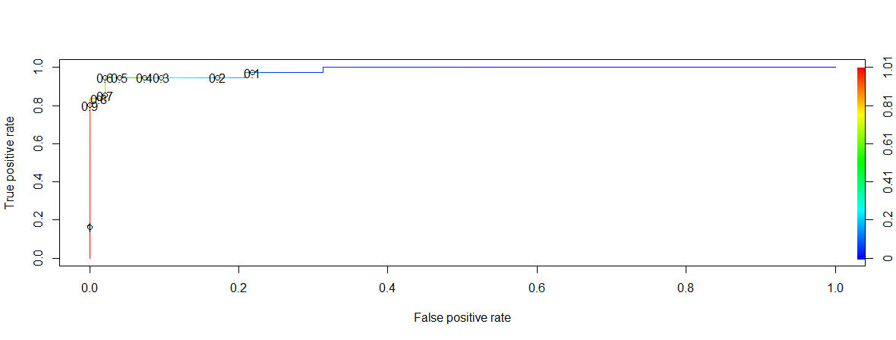

This above graph shows most of the values have less False Positive rate and high true positive rate. This explains the accuracy of the predictions.

In the similar way as mentioned above, there are few other variables which can be considered as dependent variable, which is based on the coefficients in the summary of linear regression model.

#Creating Logistic Regression model for fruity.  
lgmodel1<-glm(candy$fruity~.-competitorname,family = "binomial", data = candy)

## Warning: glm.fit: fitted probabilities numerically 0 or 1 occurred

#This give the summary of the coeffient values.  
summary(lgmodel1)

##   
## Call:  
## glm(formula = candy$fruity ~ . - competitorname, family = "binomial",   
## data = candy)  
##   
## Deviance Residuals:   
## Min 1Q Median 3Q Max   
## -2.31356 -0.00015 0.00000 0.37786 1.87302   
##   
## Coefficients:  
## Estimate Std. Error z value Pr(>|z|)   
## (Intercept) -1.80206 2.08682 -0.864 0.38784   
## chocolate -4.89569 1.57889 -3.101 0.00193 **  
## caramel -3.34322 1.49252 -2.240 0.02509 *   
## peanutyalmondy -19.69040 3645.42314 -0.005 0.99569   
## nougat 0.08994 6118.66419 0.000 0.99999   
## crispedricewafer -16.15216 4832.04683 -0.003 0.99733   
## hard 1.32752 1.08925 1.219 0.22294   
## bar -17.98457 3792.23776 -0.005 0.99622   
## pluribus -0.84050 1.09153 -0.770 0.44129   
## sugarpercent 0.62164 1.59447 0.390 0.69663   
## pricepercent 1.52698 2.04288 0.747 0.45478   
## winpercent 0.07850 0.04819 1.629 0.10332   
## ---  
## Signif. codes: 0 '***' 0.001 '**' 0.01 '*' 0.05 '.' 0.1 ' ' 1  
##   
## (Dispersion parameter for binomial family taken to be 1)  
##   
## Null deviance: 116.880 on 84 degrees of freedom  
## Residual deviance: 38.914 on 73 degrees of freedom  
## AIC: 62.914  
##   
## Number of Fisher Scoring iterations: 19

#Predict the values and also to check the accuracy of the model.  
res1 <- predict(lgmodel1,candy,type = "response")  
#confusion matrix  
table(ActualValue = candy$fruity, PredictedValue = res1 > 0.5)

## PredictedValue  
## ActualValue FALSE TRUE  
## 0 41 6  
## 1 3 35

#accuracy  
(41+35)/(41+3+6+35)

## [1] 0.8941176

require(ROCR)  
#define the ROCRPrediction and ROCRPerformance variables,this is used to plot a graph.  
acuracyPD <- prediction(res1,candy$fruity)  
acuracyPF <- performance(acuracyPD,"tpr","fpr")  
#plotting the graph  
plot(acuracyPF, colorize = TRUE,print.cutoffs.at = seq(0.1,by=0.1))

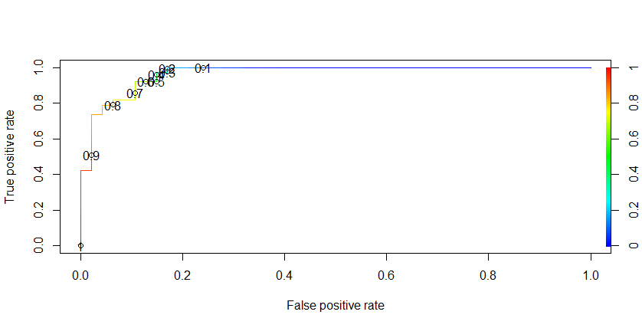

#Creating Logistic Regression model for peanutyalmondy.  
lgmodel2<-glm(candy$peanutyalmondy~.-competitorname,family = "binomial", data = candy)

## Warning: glm.fit: fitted probabilities numerically 0 or 1 occurred

#This give the summary of the coeffient values.  
summary(lgmodel2)

##   
## Call:  
## glm(formula = candy$peanutyalmondy ~ . - competitorname, family = "binomial",   
## data = candy)  
##   
## Deviance Residuals:   
## Min 1Q Median 3Q Max   
## -1.30088 -0.43467 -0.00006 0.00000 2.67591   
##   
## Coefficients:  
## Estimate Std. Error z value Pr(>|z|)   
## (Intercept) -5.38613 2.30768 -2.334 0.0196 *  
## chocolate -1.70693 1.56131 -1.093 0.2743   
## fruity -19.45599 2552.30613 -0.008 0.9939   
## caramel -1.02308 1.02425 -0.999 0.3179   
## nougat 0.62718 1.37196 0.457 0.6476   
## crispedricewafer -1.90396 1.42227 -1.339 0.1807   
## hard -15.59314 3606.56686 -0.004 0.9966   
## bar -0.40264 1.58635 -0.254 0.7996   
## pluribus -0.37066 1.32482 -0.280 0.7796   
## sugarpercent -0.10079 1.76974 -0.057 0.9546   
## pricepercent 2.87643 2.37264 1.212 0.2254   
## winpercent 0.08498 0.04029 2.109 0.0349 *  
## ---  
## Signif. codes: 0 '***' 0.001 '**' 0.01 '*' 0.05 '.' 0.1 ' ' 1  
##   
## (Dispersion parameter for binomial family taken to be 1)  
##   
## Null deviance: 76.057 on 84 degrees of freedom  
## Residual deviance: 43.485 on 73 degrees of freedom  
## AIC: 67.485  
##   
## Number of Fisher Scoring iterations: 19

#Predict the values and also to check the accuracy of the model.  
res2 <- predict(lgmodel2,candy,type = "response")  
#confusion matrix  
table(ActualValue = candy$peanutyalmondy, PredictedValue = res2 > 0.5)

## PredictedValue  
## ActualValue FALSE TRUE  
## 0 67 4  
## 1 5 9

#accuracy  
(67+9)/(67+4+5+9)

## [1] 0.8941176

require(ROCR)  
#define the ROCRPrediction and ROCRPerformance variables,this is used to plot a graph.  
acuracyPD <- prediction(res2,candy$peanutyalmondy)  
acuracyPF <- performance(acuracyPD,"tpr","fpr")  
#plotting the graph  
plot(acuracyPF, colorize = TRUE,print.cutoffs.at = seq(0.1,by=0.1))

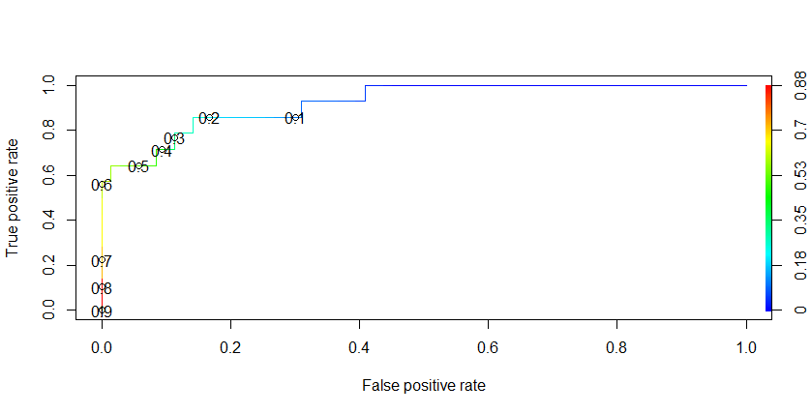

for Chocolate:

#accuracy  
(47+35)/(47+1+2+35)

## [1] 0.9647059

for Fruity:

#accuracy  
(41+35)/(41+3+6+35)

## [1] 0.8941176

for Peanutyalmondy:

#accuracy  
(67+9)/(67+4+5+9)

## [1] 0.8941176

From the above comparison among different accuracies of different variables, the accuracy is more for chocolate. From that we can draw the conclusion for my research question that the candy with more chocolate has the highest demand.

**RATTLE DECISION TREE:**

Implementation of Decision tree by using Rattle:

install.packages("rattle")

library(rattle)

install.packages("tibble")

library(tibble)

install.packages("bitops")

library(bitops)

rattle()

install.packages("RGtk2")

library(RGtk2)

after running these libraries that rattle environment has popped up.

But to get the answer for my research question what the best candy is. Have a column which says the winpercent of each candy. With the help of that we can find best candy with successful variable which is chocolate. As you can see in the dataset. Let us see top 10 winpercent candies, all then has the chocolate variable as 1 which means those candy contains that ingredient.

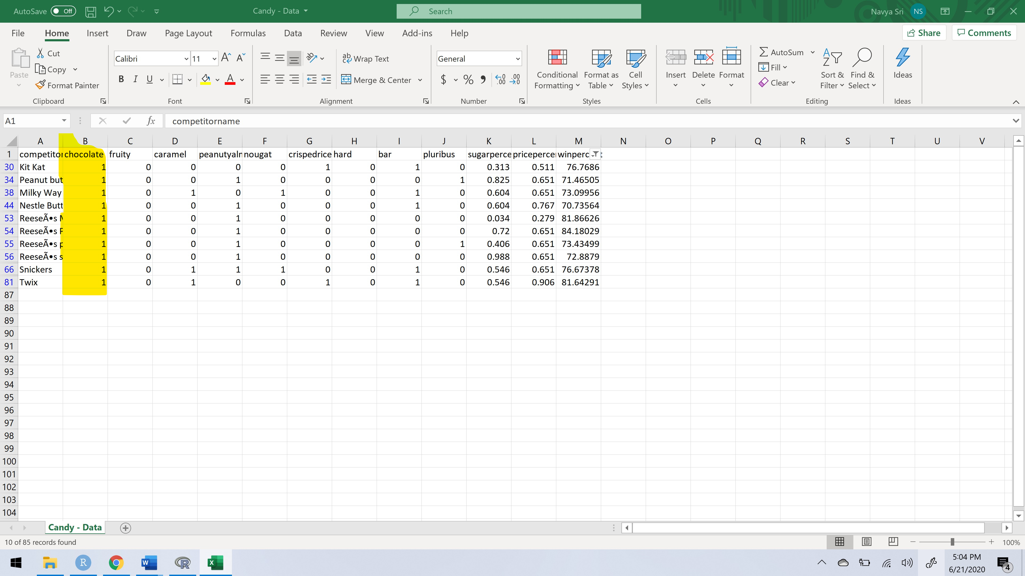

So, let’s build the tree with winpercent as the target and compitetorname as the ident.

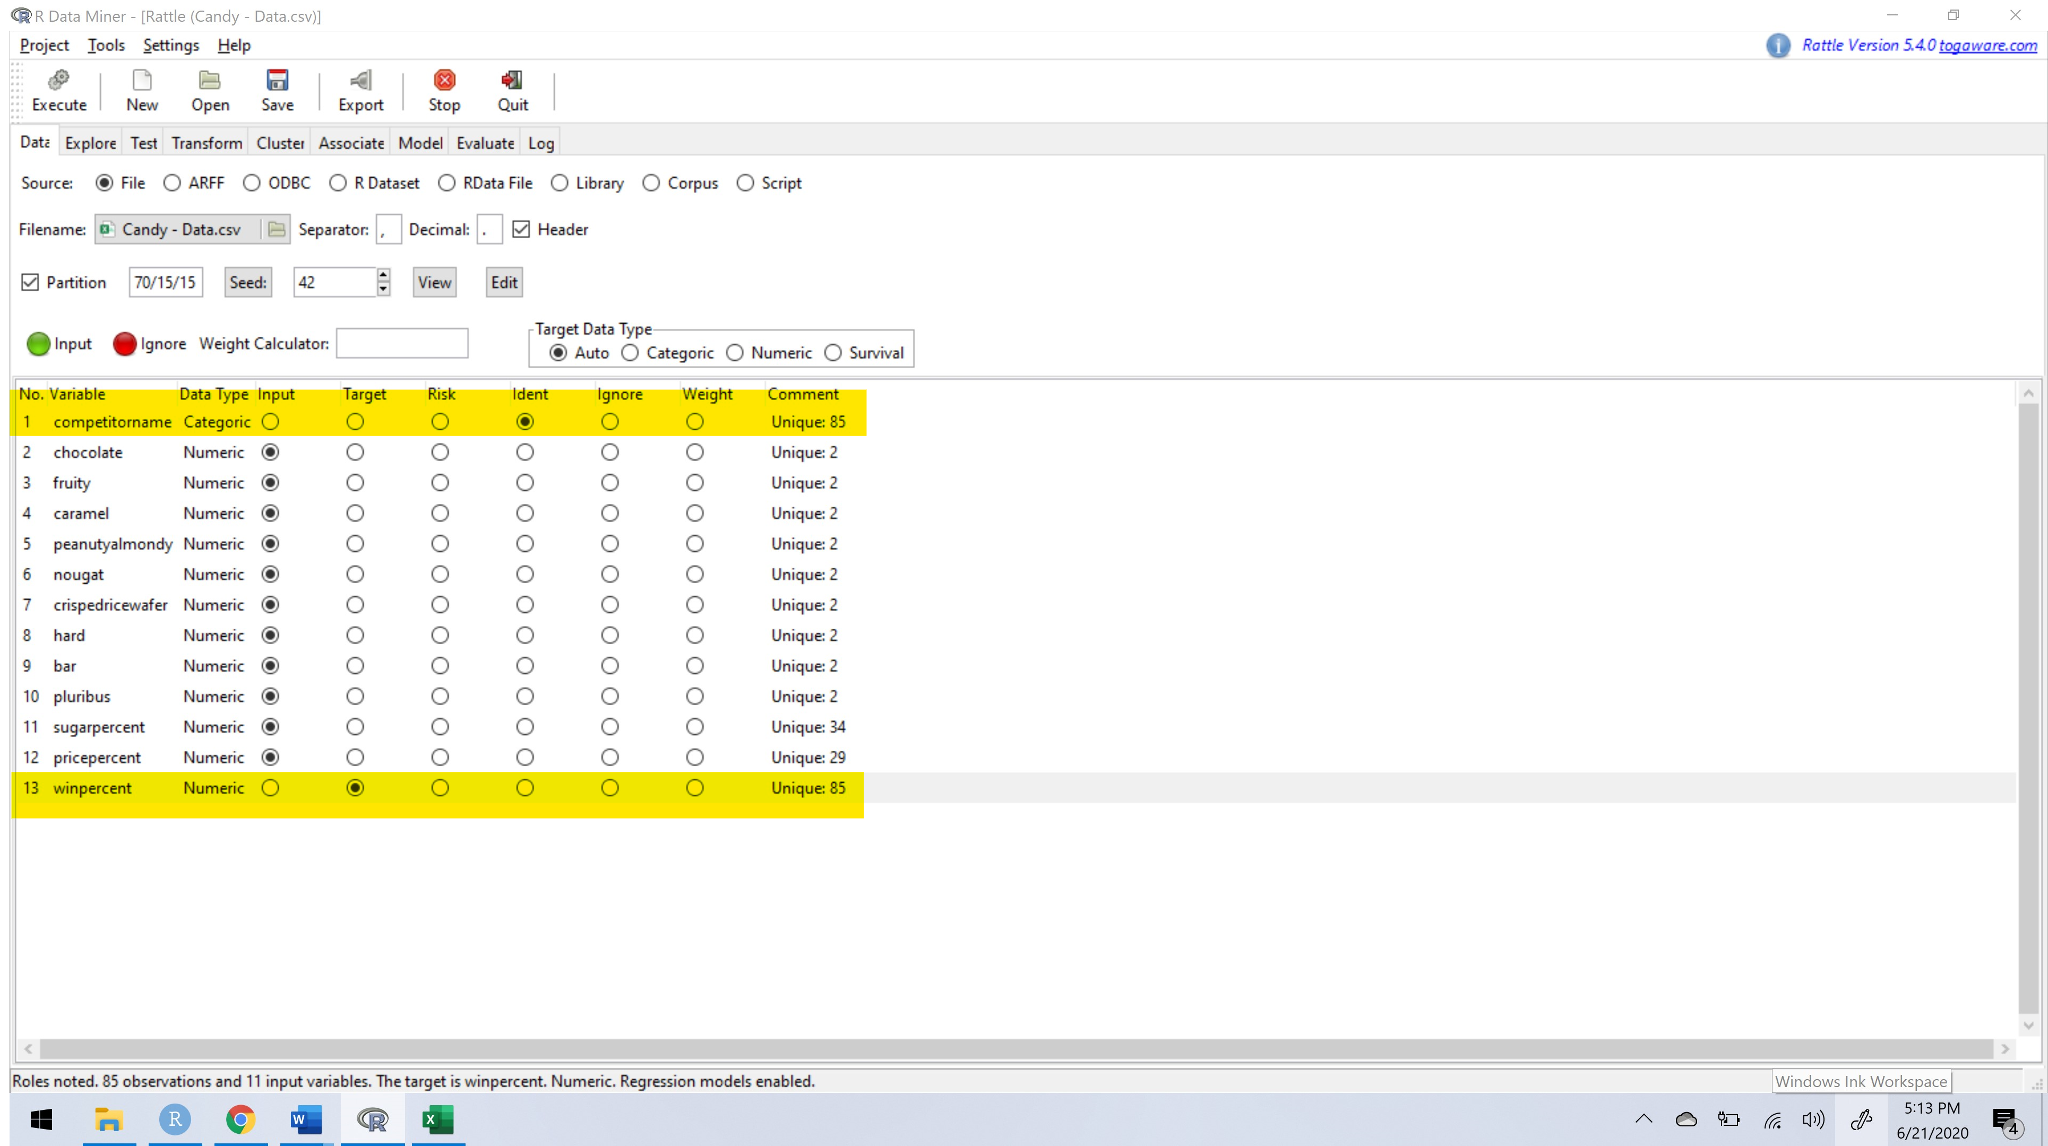

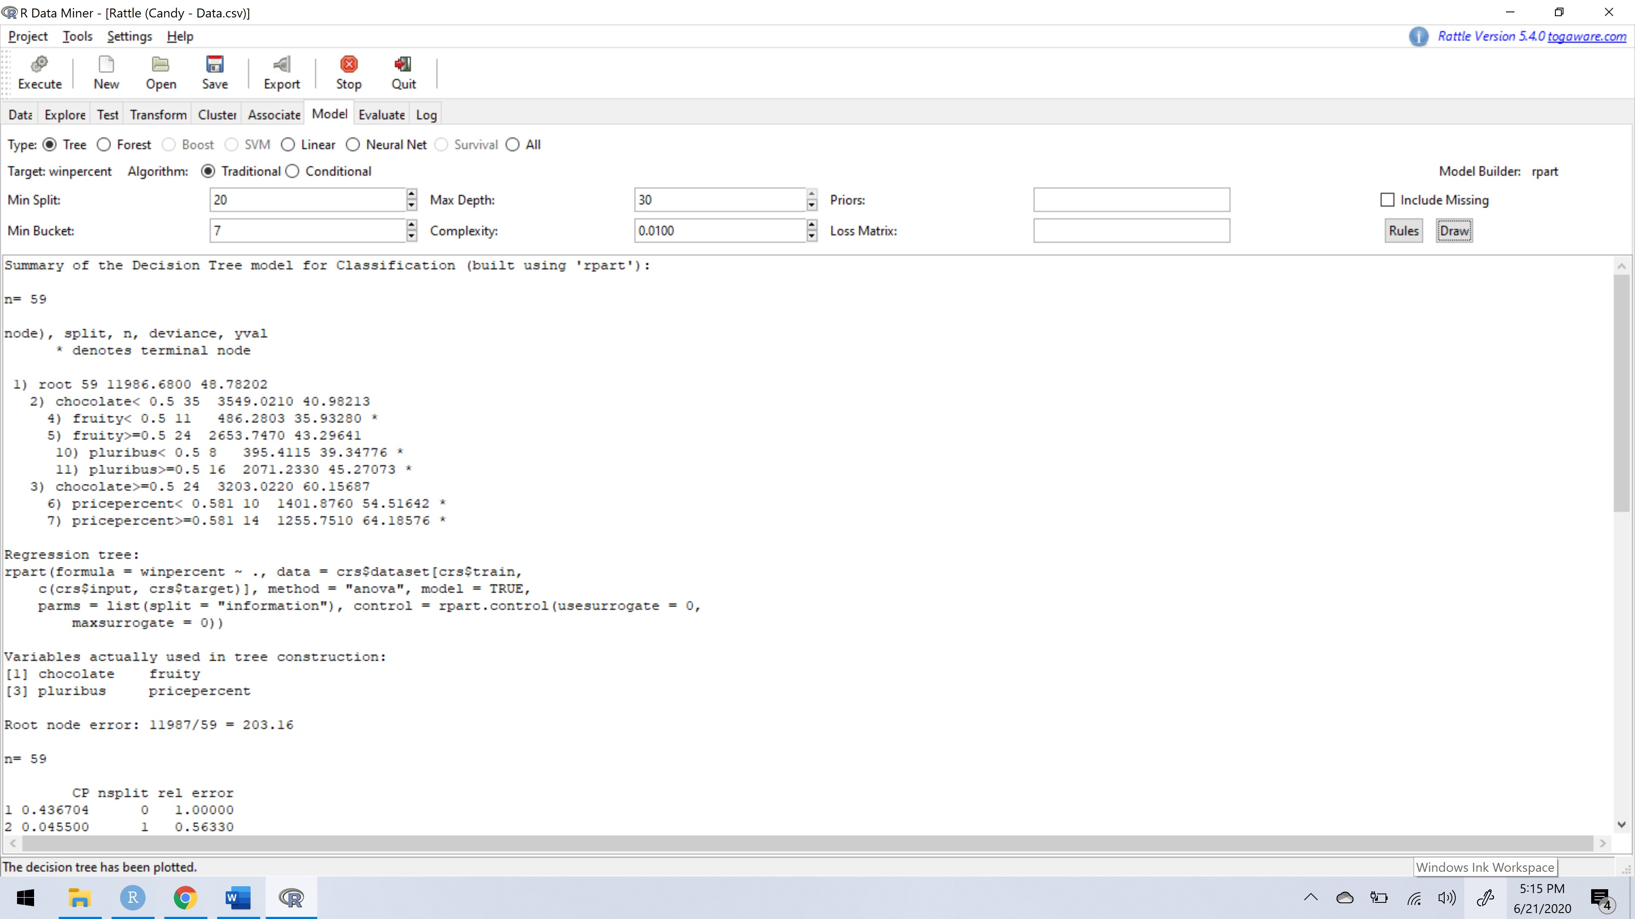

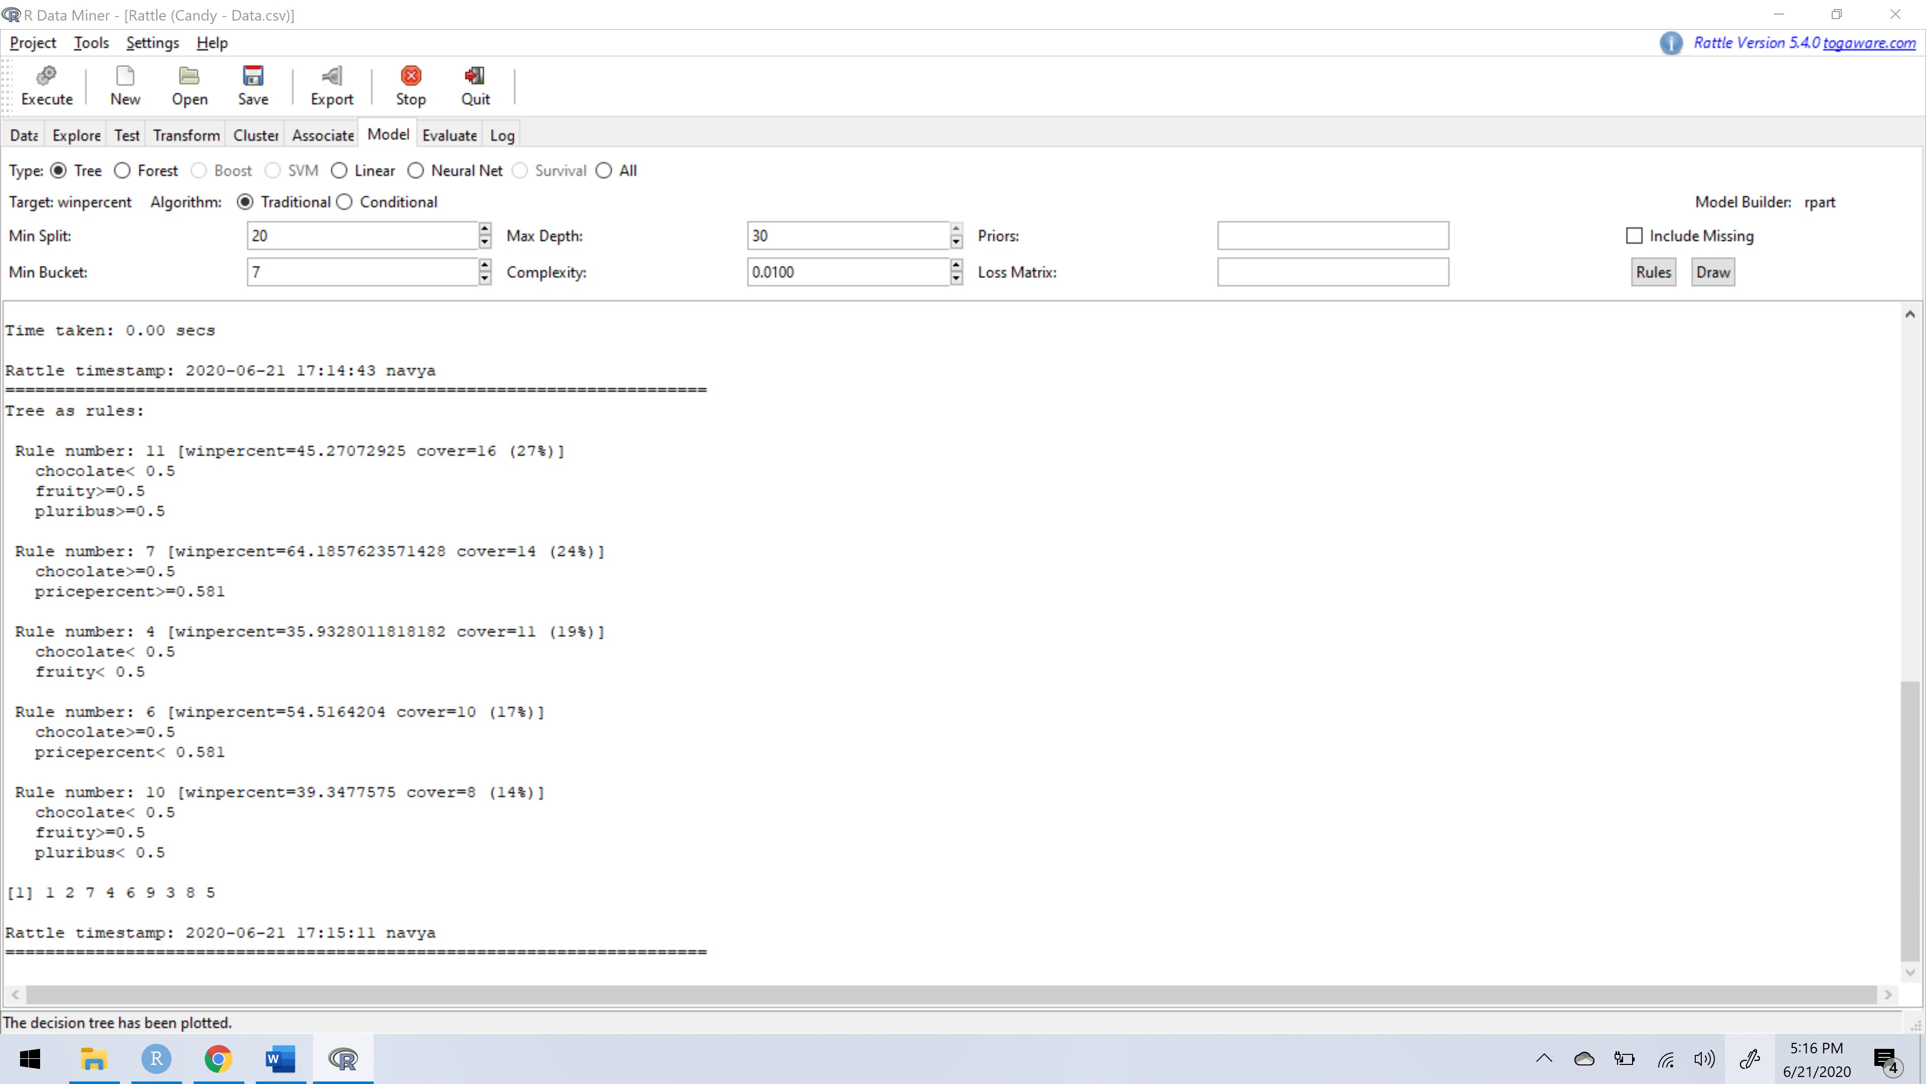

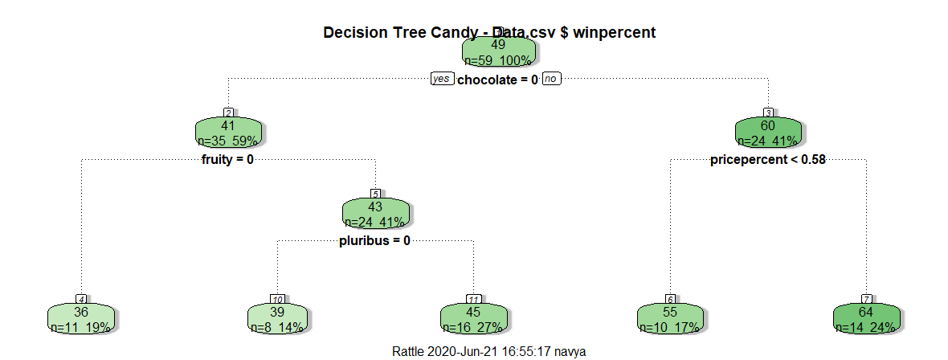

From this tree also we can draw that having chocolate has the dark green which means that has the maximum winpercent. But when compared with the linear and logistic regression models and decision tree using Rattle, I feel the regression models is apt as we can calculate the accuracy of the predicted model compare it with the other variables and find the best candy.

**Conclusion:**

I mentioned about my research question, which is: “What is the best candy during Halloween?” to figure that out I have chosen linear and logistic regression models. From linear regression model I have figured the variable which has highest confident when coefficients are calculated, as you can see below:

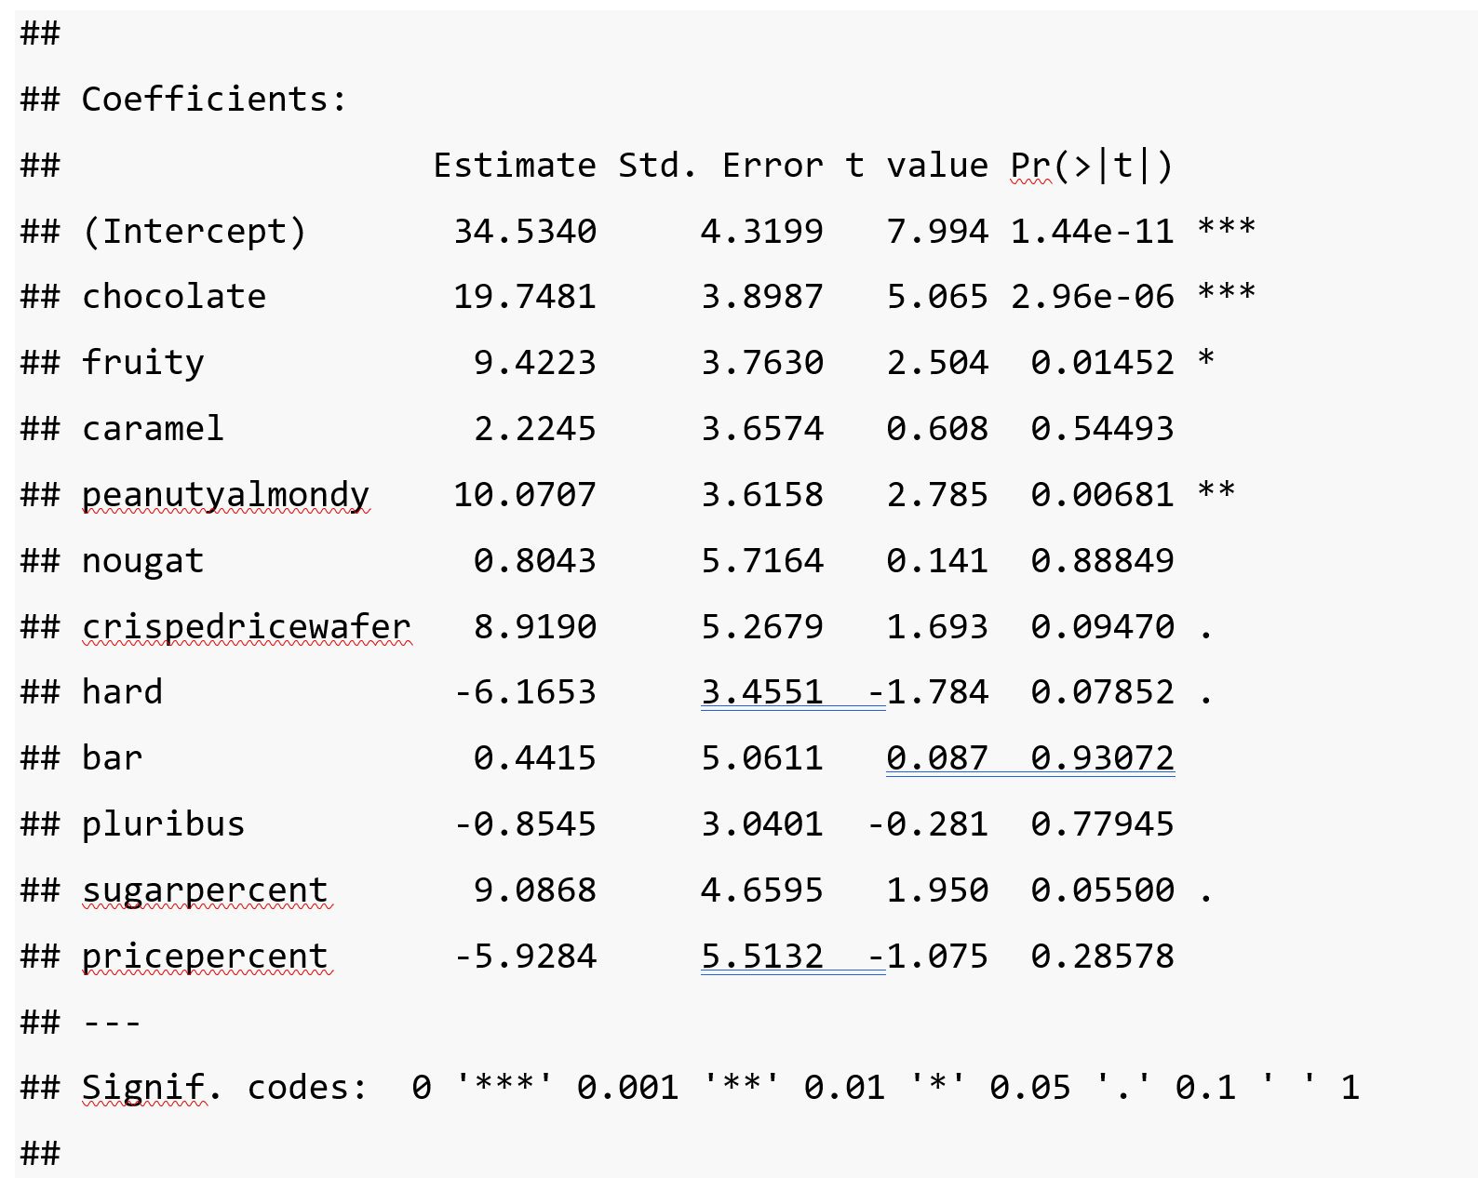

           Here chocolate has three * which indicates the 99.9% confident which means if we consider this variable, we can predict the most accurate values.

           By considering this variable I have create a logistic model to measure the accuracy that this chocolate variable we considered has more demand. To calculate accuracy, I have also built a table between actual values and predicted values which is called confusion matrix a shown below:

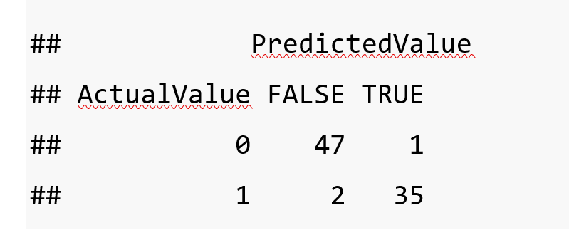

            Let me explain those values in the matrix, this is the comparison between the actual table values of the chocolate column and predicted values of the chocolate. It has 47 true that the value of chocolate is 0 in both actual table and the predicted table, only 1 time it predicted value is false. In the next case, the prediction of chocolate value is 1, in which it is 35 time true and 2 times its false. Which is a pretty good prediction

             Now to calculate the accuracy of this model we need to find its sum of the correct instances which is diagonally represented in the above matrix and divided by the total number of instances i.e.,

#accuracy  
(47+35)/(47+1+2+35)

## [1] 0.9647059

Comparing the accuracies of other variables.

for Chocolate:

#accuracy  
(47+35)/(47+1+2+35)

## [1] 0.9647059

for Fruity:

#accuracy  
(41+35)/(41+3+6+35)

## [1] 0.8941176

for Peanutyalmondy:

#accuracy  
(67+9)/(67+4+5+9)

## [1] 0.8941176

To answer my research question “what is the best candy?”, as my model suggests having the variable chocolate give the candy company profits. So, I think the candies which has chocolate ingredient are the best candies.

**References:**

1. I have researched few websites like mentioned below:

<https://archive.ics.uci.edu/ml/index.php>

<https://www.kaggle.com/datasets>

<https://catalog.data.gov/dataset>.

There are many more web services which provides us free access to the datasets.

1. I have taken this dataset from [https://www.kaggle.com/fivethirtyeight/the-ultimate halloween-candy-power-ranking/](https://www.kaggle.com/fivethirtyeight/the-ultimate%20halloween-candy-power-ranking/).
2. This dataset is Copyright (c) 2014 ESPN Internet Ventures and distributed under an [MIT license](https://github.com/fivethirtyeight/data/blob/master/LICENSE). Check out the analysis and write-up here: [The Ultimate Halloween Candy Power Ranking](http://fivethirtyeight.com/features/the-ultimate-halloween-candy-power-ranking/). Thanks to [Walt Hickey](http://walthickey.com/) for making the data available.
3. <https://www.youtube.com/watch?v=yIYKR4sgzI8>
4. <https://www.youtube.com/watch?v=nk2CQITm_eo>
5. <https://www.youtube.com/watch?v=Z5WKQr4H4Xk>
6. <http://www.learnbymarketing.com/tutorials/explaining-the-lm-summary-in-r/>
7. <http://rstudio-pubs-static.s3.amazonaws.com/491476_d4246618fe234dcfabb4284dd0f31fcf.html>
8. Rattle Implementation from Intro to Data Science Course Learning Module.